**Bidisha Gogoi**

**2023JULB01242**

LIFE INSURANCE PRODUCT FOR GEN Z

Request for Problem – Individual White Paper

**Contents**

**1. Background** 2

**1.1 Industry Overview** 2

**1.2 Company Overview** 2

**1.3. Statement of Purpose** 2

**2. Problem Framing** 3

**2.1. Broader Description of the** 3

**Problem** 3

**2.2 Visualisation of the Situation -** 3

**Situational Analysis** 3

**2.3 Articulation of the Situation** 4

**2.4 Problem Definition** 4

**2.5 Project Objectives** 5

**3. Project Execution** 5

**3.1 Conceptual framework of the** 5

**Study** 5

**3.2(a) Identification of data source** 7

**and data collection** 7

**3.2(b) Extract Relevant Information** 7

**3.3 Analysis of data** 7

**Results and Findings** 15

**4.1 Alternative Solutions Generated** 15

**4.2 Proposed Solutions & Justification** 15

**5. Conclusions** 19

**5.1 Recommendations** 19

**5.2 Limitations** 20

## **1. Background**

## **1.1 Industry Overview**

The Indian life insurance sector is a vital part of the nation's financial services industry, contributing significantly to economic stability and personal financial protection. In 2022, the Indian life insurance industry grew at a compound annual growth rate (CAGR) of 11% to 13%, driven by rising income levels, increased awareness of financial security, and tax benefits offered on premiums.

Despite this growth, life insurance coverage in India remains relatively low, with only about 3.2% of the population insured, compared to the global average of 7%. While rural India has seen a rise in micro-insurance and affordable coverage options, the younger urban population, especially Generation Z, remains largely uninsured. In 2022, IRDAI introduced several initiatives aimed at simplifying insurance products, promoting inclusivity, and encouraging digital distribution channels. However, attracting younger generations to life insurance remains a key challenge.

**Indian Life Insurance Market Structure**:

* **Private vs Public Sector**: The market is dominated by the public sector, particularly Life Insurance Corporation (LIC), which holds around 66% of the market share. Private players, including Star Union Dai-ichi Life, account for the rest.
* **Product Categories**: Life insurance products in India typically fall into categories such as Term Insurance, Endowment Plans, Unit Linked Insurance Plans (ULIPs), and Pension Plans. Term insurance is gaining popularity due to its simplicity and affordability.

## **1.2 Company Overview**

**Star Union Dai-ichi Life Insurance Co. Ltd. (SUD Life)** is a joint venture between Union Bank of India, Bank of India, and Dai-ichi Life Holdings, a

prominent life insurance provider in Japan. Founded in 2009, SUD Life is dedicated to offering innovative and affordable insurance solutions that meet the needs of Indian consumers. With access to over 9,500 branches of Union Bank and Bank of India, SUD Life has a widespread distribution network, making it one of the fastest-growing life insurers in India.

**Key Features of SUD Life:**

* **Strong Bank Partnerships:** As a bancassurance-focused insurer, SUD Life benefits from the extensive customer base of its partner banks.
* **Diverse Product Portfolio:** SUD Life offers a wide range of life insurance products, including term insurance, savings plans, endowment plans, and retirement solutions.
* **Financial Strength:** Supported by Dai-ichi Life's global expertise and the robust capital base of its partner banks, SUD Life is well-equipped to expand its operations in the Indian market.

**Company Mission**: To provide cost-effective, comprehensive, and secure life insurance solutions that cater to the diverse needs of customers while ensuring long-term growth and profitability.

## **1.3. Statement of Purpose**

The primary goal of this study is to investigate why Gen Z, a digitally savvy and financially mindful generation, has been less receptive to life insurance compared to previous generations. Despite offering a wide range of products, SUD Life, like many other insurance companies, has faced challenges in attracting this demographic. By understanding the reasons for low adoption, this research seeks to assist SUD Life in creating new products and marketing campaigns that align with Gen Z's needs and preferences.

# **2. Problem Framing**

## **2.1. Broader Description of the**

## **Problem**

Gen Z is a unique generation with specific financial behaviours and attitudes that differentiate them from older generations. Their approach to financial planning, risk management, and long-term commitments such as life insurance is influenced by

1. **Low Financial Literacy:**

* Gen Z often lacks awareness of the benefits of life insurance and how it can serve as a long-term financial tool.
* They are not exposed to the multi-dimensional features of Life Insurance.
* Their financial knowledge is generally limited to more immediate needs, such as managing debt, savings, and investments.

1. **Limited Financial Resources:**

* As non-breadwinners or individuals still reliant on parental support, many Gen Z do not yet see the need for life insurance, especially since they lack significant financial dependents.
* Many Gen Z individuals are still students or in early stages of their careers, leading to low disposable income.
* As a result, they prioritise short-term financial goals and fast returns over long-term investments like life insurance.

1. **Minimal Risk Exposure:**

* Since most Gen Z individuals are not married and do not have

dependents, they perceive low risk in their current life situation.

* Life insurance is often seen as unnecessary when there are no significant financial responsibilities.

1. **Short-term Focus and lack of patience:**

* Gen z tends to focus on the immediate concerns than the future like job loss, survival, and economic volatility.
* They are not yet planning for long-term goals like marriage, family, or retirement, which traditionally drive life insurance purchases.

1. **Already insured by parents:**
   * Many Gen Z individuals already have life insurance policies in their names through their parents, leading to a reduced sense of urgency or need to obtain their own policies.

## **2.2 Visualisation of the Situation -**

## **Situational Analysis**

Gen Z, a digitally native and financially conscious generation, often exhibits a lack of awareness and understanding of life insurance. Their focus is primarily on immediate financial needs, such as managing debt, savings, and investments, rather than long-term planning. Limited financial resources, often due to dependence on parental support or early career stages, further deter them from considering life insurance. The perception of low risk, especially among those who are single and without dependents, reinforces this disinterest. Additionally, many Gen Z individuals already have life insurance policies through their parents, reducing their sense of urgency to obtain their own. These factors collectively contribute to Gen Z's limited engagement with life insurance products.

## **2.3 Articulation of the Situation**

1. **Financial and Personal Circumstances**

* Most Gen Z individuals are still in their educational or early career stages, with limited disposable income.
* They are more focused on managing student loans, finding stable employment, and achieving financial independence.
* Given their current life stage, the typical triggers for life insurance purchases (marriage, children, long-term assets) are largely absent, resulting in low motivation to buy insurance.

1. **Complex Procedures and Lack of Transparency**

* The complexity and traditional structure of life insurance products, which often involve lengthy paperwork and unclear terms, are unappealing to this generation.
* They expect transparency, ease of use, and quick access to information, which current life insurance products lack.
* Gen Z is highly digital, making them skilled at using apps and digital tools for managing finances.
* However, despite their digital familiarity, they are cautious about committing to products they do not fully understand, such as life insurance.

1. **Needs of Gen Z Not Being Covered in Existing Life Insurance**

* Life insurance is perceived as a complex, long-term commitment that offers little immediate benefit.
* This is in stark contrast to Gen Z's preference for short-term financial products that provide tangible, quick rewards.
* The abstract nature of life insurance (protection against future risks) does not resonate with a generation focused on managing immediate economic volatility, such as educational and job-related concerns.

1. **Preference for Flexibility and Personalization Over Rigidity in Financial Products**

* They often seek flexibility in financial products.
* The rigid nature of traditional life insurance policies, with fixed premiums and long-term commitment, contrasts with their demand for more adaptable and personalized financial tools.
* They have a growing interest in products powered by technology, such as AI-driven financial planning tools.
* However, these innovations are still underutilized in the insurance industry, creating a gap between Gen Z's expectations and the products available.

## **2.4 Problem Definition**

* The primary challenge is that traditional life insurance products offered by companies are not aligned with Gen Z's financial priorities, digital preferences, and need for immediate value.
* While life insurance can provide financial security, the way it is currently marketed and sold does not resonate with Gen Z's lifestyle.
* The core problem is the low engagement and adoption of life insurance among Gen Z due to their preference for short-term, high-return investments, and a lack of understanding or trust in the traditional life insurance model.
* They perceive life insurance as irrelevant to their current needs, complicated to obtain, and lacking in immediate value.
* Their existing medical insurance coverage from employers further reduces the perceived need for life insurance, and many are not financially capable of considering long-term investment or protection products.

## **2.5 Project Objectives**

**1. Tailoring Products for Gen Z's Mindset**

* To design life insurance products that align with Gen Z's preference for short-term financial commitments, instant access, and easy, tech-driven processes.
* These products should provide quick, visible benefits to encourage adoption.

**2. Enhancing Life Insurance Awareness**

* To leverage social media, influencers, and peer networks to promote life insurance products and increase Gen Z's trust in insurance companies.
* Integrating life insurance awareness into platforms that Gen Z already engages with can boost familiarity and trust.

**3. Increasing Financial Literacy and Awareness**

* To develop strategies to educate Gen Z about the importance of life insurance, particularly in managing long-term risks and protecting future assets.
* This should involve collaborations with schools, colleges, and corporates to promote insurance literacy early.

# **3. Project Execution**

## **3.1 Conceptual framework of the**

## **Study**

The rapidly evolving world has seen Gen Z emerge as a significant segment of the global population. Businesses across various sectors, including financial services, are shifting their focus to cater to this demographic. Financial product companies face the challenge of tapping into this large and potential market, which remains largely untapped due to limited understanding of Gen Z's perception of financial products.

Research has indicated that Gen Z is relatively under-informed when it comes to financial literacy, particularly around insurance products. This lack of knowledge, coupled with the perception of insurance as a complex and non-essential product, creates a gap that financial companies can leverage. Despite the growing importance of insurance, there is a noticeable lack of products tailored to meet the specific needs and preferences of Gen Z.

While some companies have started to introduce innovative insurance products, they often fail to market these offerings effectively to this segment. Gen Z, being tech-savvy and value-driven, requires more targeted marketing strategies that resonate with their preferences. Therefore, understanding Gen Z's risk perception, decision-making factors, and financial literacy levels is crucial to developing and promoting insurance products that they will adopt.

This study aims to address this gap by examining Gen Z's attitudes towards insurance, the factors that influence their decision to adopt financial products, and the role of financial literacy in shaping these behaviors. The findings will help insurance companies design and market products that are more aligned with the values and needs of this new market segment.

**Step 1: Plan for Data Collection and Analysis**

* **Objective:** Gather comprehensive insights on Gen Z's risk perception, financial literacy, and attitudes toward life insurance.
* **Data Collection Methods:** Focus group discussions and a questionnaire.

**Step 2: Conduct Focus Group Discussions (FGDs)**

* **Reason:** Since most of the data is qualitative, focus group discussions (FGDs) were chosen as the primary method for collecting nuanced insights.
* **Participants:** A diverse sample of Gen Z individuals with different backgrounds to ensure a broad spectrum of perspectives.

**Step 3: First Focus Group Discussion**

* **Goal:** Collect data on key factors such as:
* Gen Z's perception of life insurance.
* Risk assessment and aversion.
* Financial literacy.
* Lifestyle preferences.
* Behavioural patterns when considering financial products.

**Step 4: Categorize Data**

* **Action:** Organize the data collected from the first discussion into various categories, such as:
* Insurance perception.
* Financial decision-making.
* Risk-taking behaviour.
* Knowledge gaps.
* Product preferences.

**Step 5: Additional Focus Group Discussions**

* **Sessions:** Conduct 3 more FGDs (2 offline and 1 online) to gather broader insights. Each FGD had a participation of 6 to 8 people from the target segment.
* **Focus:** Explore deeper into the areas mentioned above and gather feedback on product expectations.

**Step 6: Distribute Questionnaire**

* **Objective:** Identify gaps in current insurance offerings and understand Gen Z's product expectations.
* **Design:** The questionnaire should include Likert-scale questions and open-ended questions to cover:
* Shortcomings of existing insurance products.
* Desired features and expectations from an insurance product tailored for Gen Z.
* Importance of digital engagement, cost, and customization.

**Step 7: Analyse Questionnaire Data**

* **Method:** Use pictorial representations (e.g., bar graphs, pie charts) to visually summarize responses, particularly for Likert-scale data and preferences. Collected 50 responses.
* **Focus:** Identify patterns, preferences, and significant areas of dissatisfaction with existing products.

**Step 8: Compile and Classify FGD Data**

* **Action:** Synthesize qualitative insights from all FGDs, grouping similar responses and contrasting differing opinions.
* **Structure:** Categorize the data under headings like financial literacy, risk perception, and product preference to make the analysis comprehensive and organized.

**Step 9: Present Final Findings**

* **Objective:** Provide a clear and concise presentation of findings, which should include:
* Major trends in Gen Z's perception of life insurance.
* Key risk factors and financial literacy gaps.
* What Gen Z expects from an insurance product.
* How current products fail to meet their needs.
* Recommendations for designing and marketing a tailored insurance product for Gen Z.

## **3.2(a) Identification of data source**

## **and data collection**

**a) Company Website:**

* Gather information on current insurance products, offerings, and how they are marketed to Gen Z.

**b) Surveys Conducted:**

* Collect data through questionnaires, focusing on Gen Z's expectations, knowledge gaps, and dissatisfaction with existing insurance products.
* By distributing a Google form, we collected 50 responses.

**c) Focus Group Discussions (FGDs):**

* Obtain in-depth qualitative insights on Gen Z's perceptions of life insurance, risk assessment, and financial literacy.
* A total of 4 FGDs were conducted to gather input and insights from the target audience.

## **3.2(b) Extract Relevant Information**

Focused groups key points are segregated and each of them are tabled under 7 categories:

* Lifestyle Factors
* Behavioural Attitudes Towards Life Insurance
* Preferences for Life Insurance Products
* Perception of Risk and Insurance
* Influencing Factors for Life Insurance Adoption
* Challenges in Insurance Uptake
* Opportunities for Life Insurance Companies

Inputs from the questionnaire are subjected into tabular format and charts for segregation.

## **3.3 Analysis of data**

**3.3.1. Inputs From Focused Group Discussion**



**3.3.2. Inputs from Questionnaire**

**Table 2: Table for preferred type of Insurance from the circulated questionnaire**

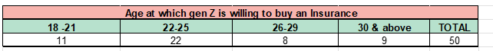

**Table 3: Table of age preference for willingness to purchase an insurance from the circulated questionnaire**

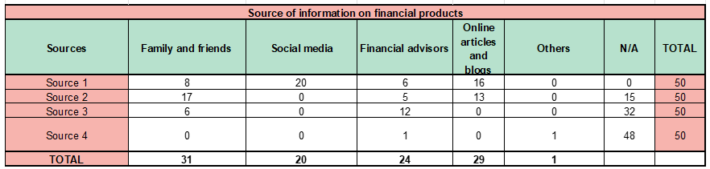

**Table 4: Table for GenZ’s source of information on financial products from the circulated questionnaire**

**Table 5: Table for GenZ’s investments in financial products from the questionnaire circulated**

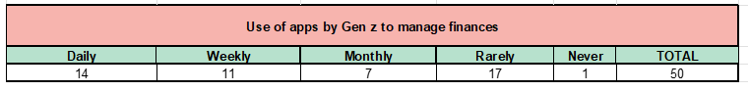**Table 6: Table for GenZ’s usage time of apps to manage their finances from the circulated questionnaire**

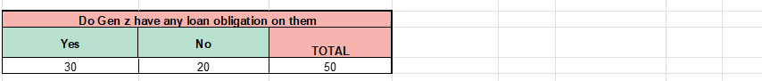

**Table 7: Table for GenZ’s loan obligations from the circulated questionnaire**

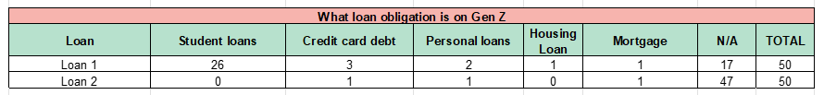

**Table 8: Table for GenZ’s category of loan obligations from the circulated questionnaire**

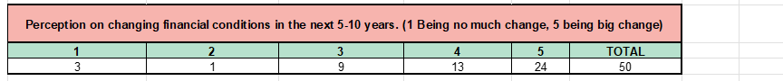

**Table 9: Table for GenZ’s perception on their changing financial conditions in next (5-10) years**

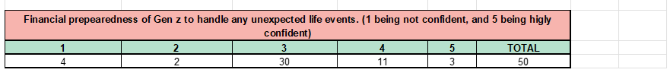

**Table 10: Table for GenZ’s financial preparedness to handle any unexpected life events from the circulated questionnaire**



**Table 11: Table for GenZ’s most used Social Media App from the circulated questionnaire**

**Table 12: Table for GenZ’s regular engagement activities from the circulated questionnaire**

**Table 13: Table for GenZ’s preference towards emergency fund from the circulated questionnaire**

**Table 14: Table for GenZ’s perception of job security importance while choosing a career from the circulated questionnaire**

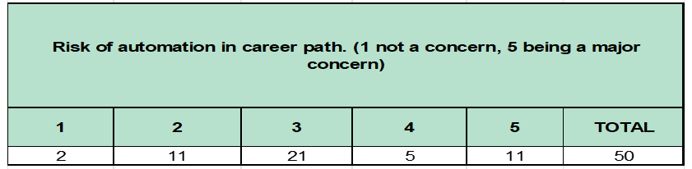

**Table 15: Table for GenZ’s perception on risk of automation in career path from the circulated questionnaire**

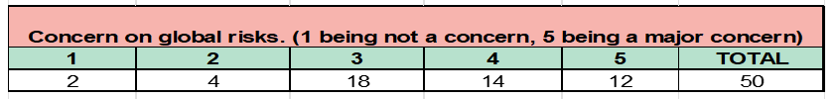

**Table 16: Table for GenZ’s concern from the circulated questionnaire**

’**Table 17: Table for GenZ’s perception on peer influence on their financial decisions from the circulated questionnaire**

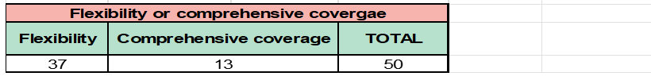

**Table 18: Table for GenZ’s perception of flexibility or comprehensive coverage in insurance from the circulated questionnaire**

**3.3.3. Charts**

**Figure 1: Graph depicting age at which GenZ is willing to buy an insurance**

**Figure 2: Graph depicting Gen Z’s preference towards emergency fund**

**Figure 3: Graph depicting importance of job security while choosing a career**

**Figure 4: Graph depicting GenZ’s perception**

**on risk of automation in career path**

**Figure 5: Graph depicting GenZ’s concern on**

**on global risks**

**Figure 6: Graph depicting GenZ’s loan obligation**

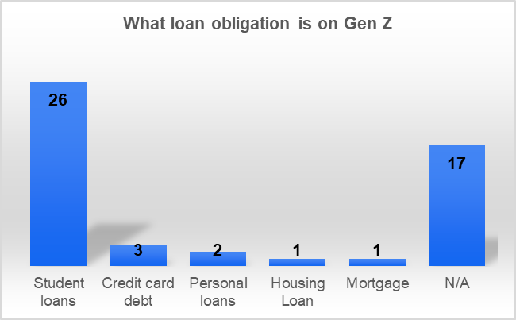

**Figure 7: Graph depicting financial preparedness of GenZ to handle unexpected life events**

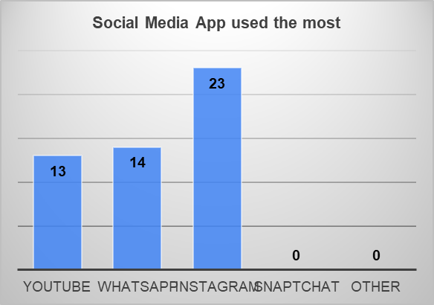

**Figure 8: Graph depicting GenZ’s perception on changing financial conditions in the next (5-10) years**

**Figure 9: Graph depicting peer influence on GenZ’s financial decisions**

**Figure 10: Graph depicting GenZ’s loan obligations**

**Figure 11: Graph depicting the most used social media apps by GenZ’s**

**Figure 12: Graph depicting the usage of apps by GenZ’s to manage their finances**

# **4. Results and Findings**

## **4.1 Alternative Solutions Generated**

**Lack of Insurance Awareness:** Gen Z has limited knowledge about insurance products and their benefits.

**Low Financial Literacy:** This demographic has minimal financial literacy.

**Parental and Corporate Influence:** Those who already have insurance typically obtain it through employers or parents, suggesting these groups are the right targets.

**Risk Mitigation Focus:** Gen Z primarily perceives insurance as a risk mitigation tool, not as an investment product.

**Delayed Insurance Purchase:** They believe it is not the appropriate age to purchase insurance.

**Dependency-Based Insurance:** Gen Z sees no need for insurance unless they have dependents.

**Wealth Creation Priority:** Their primary focus is on wealth creation for at least the next seven years, and they see no need for insurance without assets.

**Neutral Perception of Existing Products:** Gen Z does not view existing insurance products negatively, but they don't consider them relevant to their current needs.

**Ineffective Marketing:** Insurance companies' marketing strategies often fail to effectively target Gen Z, who have distinct needs and preferences that are not adequately addressed.

**Health Insurance Priority:** Health insurance should be prioritized, especially for Gen Z individuals who are living away from home.

**Essential Health Coverage**: This coverage is crucial for addressing potential emergencies and ensuring access to necessary healthcare services.

**Lifestyle-Based Risks:** Gen Z's lifestyle poses various risks that should be considered in insurance offerings. Their unique circumstances and living situations may expose them to different types of risks compared to other demographics.

**Limited Assets:** Gen Z's primary assets are often limited to electronics and a few luxury items.

**Human Touch Preference:** Gen Z prefers insurance products that incorporate a human touch rather than being fully digital.

**Flexibility in Insurance:** Flexibility in insurance products is crucial for Gen Z, as they prioritize financial survival, which includes managing loan repayments and adapting to changing financial situations.

## **4.2 Proposed Solutions & Justification**

**Any insurance product aimed at Gen Z should focus on the following points**:

**Problem Identified:** **Financial Literacy**

**Proposed Solutions:**

* **Short videos** on Instagram and YouTube explaining the product and its benefits

**Justification:** **Short Attention Span:** Given Gen Z's limited attention span, it's crucial to summarize the product and educate them through their preferred digital platforms. **Effective Marketing:** Using Instagram and YouTube can help capture Gen Z's attention and market the product more effectively.

* **Blogs** on recent financial news by SUD on their LinkedIn page and other social media platforms.

**Justification: Gen Z's Information Source:** A significant portion of Gen Z relies on blogs and articles for financial sector updates. **Leveraging LinkedIn:** LinkedIn, a popular platform among Gen Z, is an ideal place to share content. Posting relevant and engaging blogs on LinkedIn can attract their attention and increase product visibility.

* **Collaborating with B schools** to conduct seminars and interact with the target audience.

**Justification: Business School Partnerships:** Collaborating with business schools in India can be beneficial, as many mandate health insurance for their students. **Conducting Seminars:** Conducting seminars or interactive sessions in these schools is an effective way to connect with Gen Z and raise awareness about insurance products.

**Problem Identified:** **Target Marketing**

**Proposed Solutions:**

* **Ad Films Highlighting Gen Z's Risk Perception**: Create ad films that focus on the specific risks perceived by Gen Z, such as job instability, financial challenges, or uncertainties in the future. This will make insurance seem relevant to their current mindset

**Justification:** **Outdated Advertising:** Many current ads feature a traditional family structure with a middle-aged male as the sole breadwinner, which is no longer reflective of today's reality. **Modernizing Ad Concepts**: With the increasing prevalence of dual-income households and delayed family planning, it's crucial to update these ad concepts to reflect the current trends.

* **Relatable Concepts**: Use scenarios that resonate with Gen Z, such as starting a career, side hustles, or managing student debt, to demonstrate the importance of life insurance. Show how insurance can provide a safety net during these transitional life stages.

**Justification:** **Lack of Dependents:** Many Gen Z individuals do not have dependents, which is traditionally portrayed as the primary risk covered by life insurance. **Shifting the Narrative:** Advertisements need to focus on other relevant risks, such as income protection or debt management, rather than solely emphasizing dependents.

* **Leveraging Peer Influence**: Peer influence is powerful among Gen Z. Incorporate testimonials or real-life stories from their peers to build trust and credibility. Social proof can help normalize insurance as a practical decision

**Justification: Trend-Following Behaviour:** Gen Z often follows trends, and peer influence significantly impacts their decisions. **Leveraging Peer Endorsements:** Advertisements should highlight peer recommendations and endorsements to make insurance appear as a popular and desirable choice.

* Ensure that the ads are displayed on the platforms where Gen Z spends most of their time, such as Instagram, YouTube, or TikTok. The right media mix will maximize reach and engagement

**Justification: Shifting Away from Television:** In today's digital age, traditional television ads are less effective in capturing Gen Z's attention. **Focusing on Digital Channels:** Advertisers should concentrate on streaming services, social media platforms, and digital channels where Gen Z is more active to effectively engage this audience.

**Problem Identified:** **Complexity of product**

**Proposed Solutions:**

* **Use of Simple Language**: Ensure that the product features, terms, and conditions are explained in clear and straightforward language. Avoid jargon or overly technical terms that can confuse or overwhelm Gen Z, who prioritize transparency and simplicity.

**Justification: Complex Language:** The language used to describe insurance terms and conditions is often too complicated for the average consumer, particularly Gen Z. **Simplifying Language:** Simplifying the language and making it more accessible will increase understanding and trust in the product.

* **Third-Party Agent for Onboarding**: Introduce a third-party agent or platform to streamline and simplify the onboarding process. This can ease the burden of understanding complex procedures, providing personalized guidance and improving the overall customer experience

**Justification: Importance of a Third-Party Agent:** Despite the potential for digitalization, a dedicated third-party agent can significantly reduce complexity by assisting the insured in understanding the product, answering questions, and providing ongoing support. **Enhancing Reliability and Customer Relationships:** This approach fosters a better relationship with the customer by increasing reliability and providing personalized assistance.

* **Concise Terms and Conditions**: Summarize all the terms and conditions into a maximum of two pages. A short, easy-to-understand document will help Gen Z feel more confident in their decision-making and reduce the hesitation associated with complex legal language

**Justification: Short Attention Span:** Gen Z values efficiency and brevity. **Concise Communication:** Summarizing key points and ensuring the most important information is easily digestible will help capture their interest and increase engagement.

**Problem Identified:** **Trust**

**Proposed Solutions:**

* **A third-party agent**

**Justification: Restoring Trust in Life Insurance: Negative Past Experiences:** Gen Z's trust in life insurance is low, largely due to negative experiences their parents had with agents in the past. **Building Trust:** To rebuild trust, it is essential to provide a reliable, transparent agent who genuinely understands the client's needs. **Educating and Guiding Gen Z:** This agent should focus on educating and guiding Gen Z through the process, reassuring them of the product's value and the company's integrity. **Fostering Trust and Confidence:** By fostering a trustworthy relationship, transparency and confidence in both the insurance product and the company can be significantly improved.

**Problem Identified:** **Flexibility**

**Proposed Solutions:**

* **Pay-As-You-Choose Features**: Offer a customizable insurance plan where Gen Z can start with a basic plan at a minimal premium and then modify it by adding features of their choice. This flexibility allows them to pay only for what they value, making the product more appealing and tailored to individual needs

**Justification: Eliminating Unnecessary Features: Tailored Products:** Traditional insurance products often include features that Gen Z perceives as unnecessary, leading to higher premiums. By offering a flexible product that allows them to choose only the benefits they need, Gen Z can create a more personalized plan and pay only for what is relevant to them. **Cost-Effectiveness and Appeal:** This not only enhances personalization but also makes the product more cost-effective and appealing to this generation.

* **Monthly Benefit Customization**: Provide the option for policyholders to add or modify benefits monthly. This allows Gen Z to adapt their coverage according to changing needs or circumstances, ensuring the policy remains relevant and dynamic throughout different life stages.

**Problem Identified:** **Added Benefits**

**Proposed Solutions:**

* **Tailored Benefits:** Offer insurance packages that align with Gen Z's perceived needs and priorities, such as mental health coverage, flexible payment options, and sustainable investment opportunities

**Justification:** Health insurance provides Gen Z with the freedom to pursue their education and career goals without worrying about unexpected medical expenses, especially when living independently.

* **Emergency Access in Health insurance:** Provide a convenient and efficient way for Gen Z to access emergency funds from their health insurance policy, perhaps through a mobile app or online portal.

**Justification: Economic Uncertainty:** Job protection insurance can offer financial stability during periods of economic downturn or job loss, which are becoming more frequent due to technological advancements and global economic trends.

* **Income Protection:** Offer comprehensive income protection plans that cover a variety of scenarios, including job loss, illness, and disability, to provide financial security during challenging times.

**Justification:** Given Gen Z's reliance on technology for work, education, and social interactions, protecting their electronic devices is essential to maintain their productivity and quality of life.

* **Electronic Device Insurance:** Provide coverage for electronic devices, such as smartphones, laptops, and tablets, with options for theft, loss, and accidental damage

**Justification: Liquidity and Flexibility:** Offering flexible withdrawal options for insurance policies can provide Gen Z with the financial flexibility they need to cover unexpected expenses or take advantage of opportunities, without having to wait for long payout periods.

**Problem Identified:** **Transparency**

**Proposed Solutions:**

* **Transparent Communication:** Provide clear and concise explanations of terms and conditions, using plain language and avoiding jargon. Offer additional resources, such as FAQs or video tutorials, to help Gen Z understand the details of their insurance policies

**Justification: User-Friendly Experience:** Simplify the application and enrolment processes for Gen Z, making them more intuitive and accessible. **Leveraging Technology:** Consider using digital tools and technology to streamline the experience and reduce the need for complex paperwork.

* **Personalized Reminders:** Utilize technology to send personalized reminders and notifications about upcoming due dates, using their preferred communication channels (e.g., email, text, or app notifications). Allow Gen Z to customize the frequency and timing of these reminders to suit their preferences.

**Justification: Clear and Concise Information:** Present information in a clear and concise manner, breaking down complex concepts into smaller, more digestible chunks. **Visual Aids:** Use visual aids, such as infographics or diagrams, to illustrate key concepts and make the information easier to understand.

# **5. Conclusions**

# **5.1 Recommendations**

**1. Financial Literacy Programs:**

* **Targeted Initiatives:** Develop financial literacy initiatives aimed at Gen Z, utilizing platforms they frequently engage with, like LinkedIn, Instagram, and YouTube.
* **Educational Videos:** Create educational videos that simplify life insurance concepts, highlight its benefits, and address common misconceptions.

**2. Personalization of Insurance Products:**

* **Customizable Features:** Offer life insurance products with customizable features that align with Gen Z's specific life stages and financial goals.
* **Leveraging AI:** Use AI to tailor policy recommendations based on individual preferences, such as risk appetite, lifestyle, and financial goals.

**3. Simplification of Product Information:**

* **Clarity and Transparency:** Streamline the purchasing process and ensure product details are transparent and easy to understand.

**4. Targeted Marketing Strategies:**

* **Digital Campaigns:** Implement marketing campaigns specifically aimed at Gen Z on platforms like Instagram and LinkedIn.
* **Peer Influence:** Leverage peer influence by collaborating with influencers and finfluencers who resonate with this demographic.

**5. Added Benefits:**

* **Tailored Benefits:** Offer added benefits that align with Gen Z's lifestyle, values, and immediate financial concerns.
* **Short-Term Advantages:** These benefits should provide tangible, short-term advantages that resonate with their current priorities.
* **Job Security and Health Risks:** Address Gen Z's primary concerns of job security and health risks.
* **Immediate Access:** Offer financial products that provide immediate access to funds in case of emergencies.

**6. Micro-Insurance Products:**

* **Tailored Coverage:** Offer low-cost, flexible premiums through micro-insurance models.
* **Accessibility:** These policies can provide coverage for smaller sums with minimal premiums, making them accessible even to those with limited incomes.

**7. Government Collaborations:**

* **Leveraging Government Schemes:** Leverage schemes like Pradhan Mantri Jeevan Jyoti Bima Yojana to increase awareness and provide affordable insurance options.
* **Partnerships:** Create partnerships with government programs to enhance penetration in rural areas.

**8. Financial Literacy Campaigns in Vernacular Languages:**

* **Regional Language Initiatives:** Conduct insurance literacy programs in regional languages, using local influencers and community leaders.
* **Relatable Education:** Educate through simple, relatable stories to bridge the literacy gap.

**9. Mobile-Based Solutions:**

* **Mobile-First Approach:** Given the growth of mobile phone usage in rural India, insurance providers can offer mobile-based platforms that require minimal internet data.

# **5.2 Limitations**

**1**. **Financial Dependency and Purchasing Power:** Many Gen Z individuals are still financially dependent on their parents or in early career stages, limiting their ability to independently purchase life insurance. This demographic's purchasing power remains underdeveloped.

**2. Irrelevance of Life Insurance:** Life insurance is often viewed as irrelevant by Gen Z, primarily due to their current life circumstances, such as lack of dependents. This perception poses a significant barrier to adoption.

**3. Product Complexity:** The inherent complexity of life insurance products can deter Gen Z from engaging with them. Simplifying these products while maintaining regulatory compliance presents a challenge.

**4. Competitive Market:** The life insurance market is highly competitive, with numerous providers offering various products. Differentiating offerings to appeal specifically to Gen Z may require substantial investment and innovation.

**5. Economic Volatility:** Economic volatility can impact Gen Z's financial priorities and willingness to invest in long-term products like life insurance. Fluctuating job markets and financial instability may shift their focus away from insurance.

**6. Expanding Focus:** We should expand our focus to include Gen Z segments beyond urban, financially backed individuals. By studying the risk and behaviour of Gen Z in urban middle-class, urban low-income, rural rich, rural middle-class, and rural low-income groups, we can develop more inclusive and promising products.

**ANNEXURE**

**Index of Tables**

|  |  |  |
| --- | --- | --- |
| **Table Number** | **Table Name** | **Page No.** |
| 1 | Data points discussed in Focused Group Discussion | 7-8 |
| 2 | Table for preferred type of Insurance from the circulated questionnaire | 9 |
| 3 | Table of age preference for willingness to purchase insurance from the circulated questionnaire | 9 |
| 4 | Table for Gen Z’s source of information on financial products from the circulated questionnaire | 9 |
| 5 | Table for Gen Z’s investments in financial products from the circulated questionnaire | 9 |
| 6 | Table for Gen Z’s usage time of apps to manage their finances from the circulated questionnaire | 10 |
| 7 | Table for Gen Z’s loan obligations from the circulated questionnaire | 10 |
| 8 | Table for Gen Z’s category of loan obligations from the circulated questionnaire | 10 |
| 9 | Table for Gen Z’s perception on changing financial conditions in the next (5-10) years from the circulated questionnaire | 10 |
| 10 | Table for Gen Z’s financial preparedness to handle unexpected life events from the circulated questionnaire | 10 |
| 11 | Table for Gen Z’s most used Social Media App from the circulated questionnaire | 10 |
| 12 | Table for Gen Z’s regular engagement activities from the circulated questionnaire | 11 |
| 13 | Table for Gen Z’s preference towards emergency fund from the circulated questionnaire | 11 |
| 14 | Table for Gen Z’s perception of job security importance while choosing a career from the circulated questionnaire | 11 |
| 15 | Table for Gen Z’s perception on the risk of automation in career paths from the circulated questionnaire | 11 |
| 16 | Table for Gen Z’s concerns from the circulated questionnaire | 11 |
| 17 | Table for Gen Z’s perception on peer influence on their financial decisions from the circulated questionnaire | 12 |
| 18 | Table for Gen Z’s perception on flexibility or comprehensive coverage in insurance from the circulated questionnaire | 12 |

|  |  |  |
| --- | --- | --- |
| **Figure Number** | **Figure Name** | **Page No.** |
| 1 | Graph depicting the age at which Gen Z is willing to buy insurance | 13 |
| 2 | Graph depicting the age at which Gen Z is willing to buy insurance | 13 |
| 3 | Graph depicting the importance of job security while choosing a career | 13 |
| 4 | Graph depicting Gen Z’s perception of risk in career paths | 13 |
| 5 | Graph depicting Gen Z’s concern about global risks | 13 |
| 6 | Graph depicting Gen Z’s loan obligations | 13 |
| 7 | Graph depicting Gen Z’s financial preparedness to handle unexpected life events | 14 |
| 8 | Graph depicting Gen Z’s perception of changing financial conditions in the next 5-10 years | 14 |
| 9 | Graph depicting peer influence on Gen Z’s financial decisions | 14 |
| 10 | Graph depicting Gen Z’s loan obligations | 14 |
| 11 | Graph depicting the most used social media apps by Gen Z | 14 |
| 12 | Graph depicting the usage of apps by Gen Z to manage their finances | 14 |

**Index of Figures**